Facilities Management has been assigned as a point of control for Sonoma State University state owned or leased vehicles and electric and gas carts (with noted exceptions) as required by Executive Order 691 and Educational Code 89031.5 and California State University-Use of University and Private Vehicles Policy Guidelines. All require that a campus motor vehicle inspection program be established and adhered to.

These regulations are intended for the safety of the vehicle operators and the general public as well as for the general life cycle of the vehicles. It is important to comply with the following regulations and guidelines.
POLICIES & PROCEDURES

VEHICLE MAINTENANCE

- Maintenance: In order to guarantee the maximum useful life of State-owned or leased vehicles and for the safety of drivers, safety checks and maintenance inspections are outlined below:

Safety Checks:
It is the responsibility of the department that owns/lease the vehicle to ensure its operators comply to the CSU Use of University and Private Vehicle Guidelines. This includes, but is not limited to verifying each operator meets the criteria to driving State vehicles, report vehicle accidents to campus Police Services, commit to vehicle maintenance schedule as outlined by Facilities Management, report vehicle problems to Facilities Management in a timely manner, and maintain log of safety checks performed and provide records when requested. Please reference Appendix A for Motor Vehicle Pre-Use Safety Checklist.

Maintenance Inspections:
Facilities Management considers the type of vehicle when defining frequency of service needed and will contact each department at the time their vehicle maintenance service is required. Maintenance service is required every 4,000 miles or six months, and/or every 12,000 miles or twelve months.

Electric and Gas Powered Carts
All maintenance service for carts and non-licensed vehicles shall be done by Facilities Management and Facilities Management has the discretion to subcontract out services. A typical maintenance service may include:

- Chassis lube
- Check differential fluid
- Inspect & clean battery cables
- Check steering gear
- Check master cylinder
- Change oil & oil filter (if applicable)
- Check air cleaner (f applicable)
- Adjust brakes
- Inspect all lights
- Check tire condition for wear, pressure, etc.
- Inspect tires for nails, screws, etc.
- Inspect axle seals
- Change fuel filter (if applicable)
- Service transmission (if applicable)
- Balance wheels & rotate

Licensed Vehicles
Facilities Management coordinates all licensed vehicles for maintenance inspection services off campus. Should the third party contractor identify repairs during maintenance inspection, Facilities Management has the discretion to subcontract out the repair or perform in-house. Departments will be charged for all services provided off campus to the chartfield string provided by an authorized signer at the time of check-in.

- Repair: All repairs for carts and licensed vehicles will be charged back to departments. Repairs include but is not limited to motor replacement, batteries, tires, chargers, smog checks, cart and vehicle accessories and peripherals.

Repairs less than $350 will be charged to the department’s chartfield string provided at the appointment. Written estimates of additional repair work noted during the vehicle maintenance inspection exceeding $350 will be provided before any repair work is performed. If Facilities Management elects to use an outside vendor, Facilities Management will coordinate a written estimate by the outside vendor and submit an E-REQ for a purchase order to be issued before any repair work is performed. Upon completion of work conducted by an outside vendor, Facilities Management will complete an inspection of vehicle. This includes inspection of new vehicles purchased.

c) Replacement: Vehicle replacement policies vary according to department needs. As a general rule, upon inspection by Facilities Management, when estimated repairs exceed the value of the vehicle or evolving departmental needs render the use of the vehicle to be prohibitive, replacement or re-utilization is recommended (See Item 2 below).

d) Support: Pursuant to Executive Order No. 691, The Office of the Chancellor, through Risk Management, will assist in obtaining competent advice on related matters, and is available to assist university management in meeting their responsibilities to control the risks associated with vehicle operations. Additionally, information is routinely disseminated to the CSU from the State Department of General Services (DGS) or may be obtained by contacting DGS or accessing their web site at http://www.dgs.ca.gov/ofam/home.aspx.
Tasks
Purpose
Responsible Person
Frequency
Daily Mileage Log and Inspection
Report
Buses Fleet Vehicles
Multiple Driver Vehicles
Driver
Daily
Weekly Mileage Log and Inspection
Report
Department Assigned Vehicles
with one responsible person
Driver
Weekly
Monthly Mileage Log and Inspection
Report (vehicle use requires
additional information to be retained by
department)
Van Pools Police Vehicles
Driver
Monthly
Pre-Delivery & Acceptance Checklist
All Vehicles, Electric Carts,
Forklifts, Boomlifts, Tractors,
Mowers
Individual Department
As Requested
Vehicle Inventory
All vehciles
Mark Harlin
Annual
Weekly Maintenance Check
Electric Carts, Forklifts,
Boomlifts, Tractors, Mowers
Driver
Weekly
Regulations and Rules Compliance
Agreement
Fleet Vehicles
Driver
Per Use
Safety Inspection/Maintenance Service
Electric Carts, Forklifts,
Boomlifts, Tractors, Mowers
Facilities Management
Per Work Order/ As
Requested
Property Survey Report
All Vehicles
Mark Harlin
Vehicle to be taken out of
service
Sealed Bid/Auction Transfer of
Ownership
All Vehicles
Contracts and Procurment
Vehicle to be taken out of
service and sold as-is
Preventive Maintenance Service
All vehicles
Facilities Management
Per Work Order/ As
Requested
Motor Vehicle Inspection Program
Designated Staff
Responsible Party Contact
Facilities Management
Annual (July)
Multiple User Mileage Log
Dept. assigned vehicle with
multiple users
Driver
Daily
Drivers Risk & Responsibility
All Employers
Risk Management
Upon Hire
Operational Checklist (Glovebox)
All Vehicles
Facilities Management
Each PM Service
Motor Vehicle Inspection Program Tasks & Responsibility

VEHICLE EVALUATION

a) Disposition: To initiate disposal of a vehicle or cart, the Property Program Coordinator is contacted by the department owning the asset. Pursuant to ICSUAM Policy Manual For Contracting and Procurement, Section 5603 Contracts and Procurement “Disposal of Vehicles” (Reference: California Vehicle Code 24007 et seq.):
A campus vehicle may be discarded, traded in, or sold whenever the campus determines it is within its best interests to do so, regardless of age or mileage, or at such time as the vehicle has been determined to be unsafe for continued use, or when it no longer serves the purpose for which it was required. Options for the disposal of a vehicle can include (1) surveying it to the DGS State Surplus Property Division, (2) transferring it to the DGS Fleet Administration Division, and (3) liquidating it through competitive bidding or auction at the maximum price attainable in the open market.

The Sonoma State University Property Management Policy, in accordance with ICSUAM 3150.01, details the allowed methods and procedures to dispose of university property.

b) Surplus/Re-utilization: Pursuant to routine vehicle inspection (See Item 1), vehicles are maintained in a safe manner until such time that they are removed from service in compliance with Section 603 above or are surveyed to be removed from University inventory by the Property Program Coordinator.

c) Information Dissemination: Motor vehicle information is coordinated and interpreted by the campus Property Program Coordinator. The Property Program Coordinator is responsible for communicating and disseminating information to campus departments when requested; as changes in policies occur i.e., changes in the California Emission Requirements; or on an as-needed basis to relevant campus parties.

DOCUMENTATION AND REPORTING

- Repair Costs: Work orders and repairs performed by campus personnel, and outside vendor invoices are kept on file in the Facilities Management.

- Operating Costs: All motor vehicle expense data including labor, materials, chargebacks todepartments, and chargeback revenue is maintained within Facilities Management. Costs are calculated based on actual labor, material costs and indirect costs incurred.

- Reporting: At year-end management reports are generated by Facilities Management to quantify and reconcile any variances that may exist between chargeback revenue and expense. Final reports are readily available at Facilities Management for general review upon request.

COMPLIANCE
Full compliance with this program increases the overall safety, efficiency, and economic well-being of the campus’ vehicle and cart fleet. Facilities Management has been designated to oversee the campus’ Motor Vehicle Maintenance Program and is responsible for monitoring program compliance and provide reports regularly to the President and Vice President of Administration and Finance and Risk Management.

POLICY/PROCEDURE OWNER AND CONTACT INFORMATION
Unit Owner | Contact Name | Title | Phone | Email | Effective Date
Facilities Management | Christopher Dinno | Associate Vice President, Facilities Planning and Operations | x42870 | Christopher.dinno@sonoma.edu | 1/1/2017

Appendix A

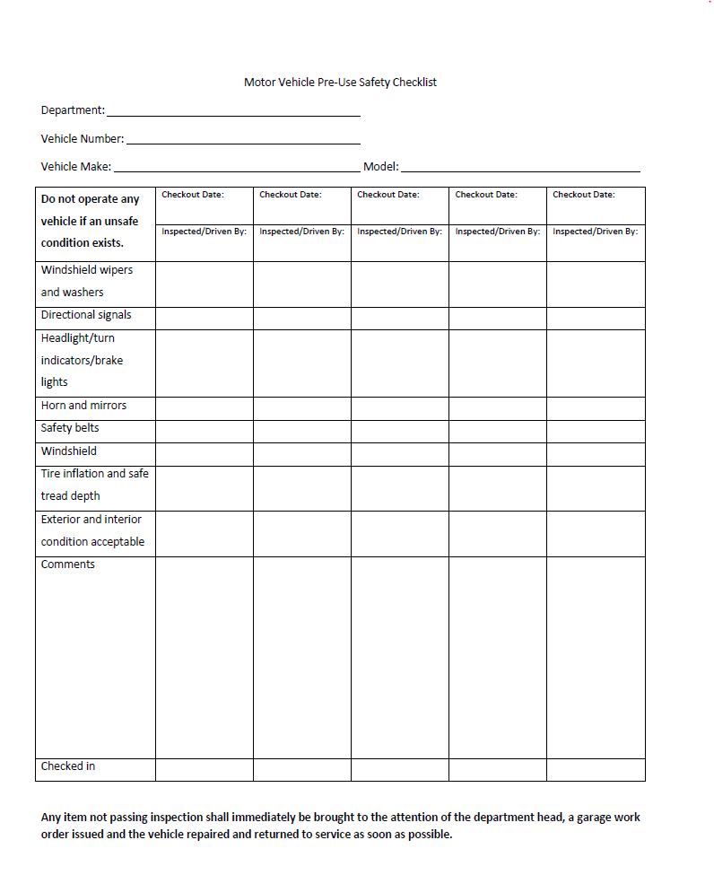

Appendix B

Resources

California State University, Risk Management
https://www.calstate.edu/risk_management/rm/

California State University, Use of University & Private Vehicles Guidelines
https://www.calstate.edu/risk_management/documents/VehicleUseGuideBook.pdf

Integrated CSU Administration Manual
http://www.calstate.edu/icsuam/sections.shtml

Executive Order 691 – Motor Vehicle Inspections – Delegation of Authority
http://www.calstate.edu/eo/eo-691.pdf

State of California - Department of General Services
http://www.dgs.ca.gov/ofam/home.aspx

