SONOMA STATE UNIVERSITY
SAFETY INFORMATION CARD
Department: |  | EXT: | 664- | Date:

Faculty Responsible: |  | Phone:
Lab Tech: |  | Phone:
Staff: |  | Phone:

HAZARDOUS CONDITIONS
Chemical Hazards |  |  | 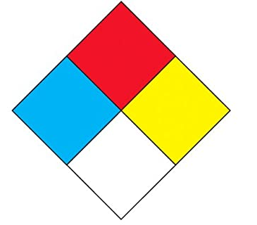  4= Severe  3= Serious  2= Moderate  1=Slight  0=Minimal  Instability  Specific Hazard  Health  Flammability
☐ Air/Water Reactive
☐ Carcinogens
☐ Corrosives
☐ Flammable/Ignitable Liquids
☐ Gas Cylinders
☐ Flammable
☐ Poison
☐ Oxidizers
☐ Poisons
☐ Waste Chemicals
BIOHAZARDS |  | PERSONAL PROTECTION |  |  | RADIATION HAZARDS
☐ Level 1 (low) |  | ☐ Safety Glasses/Goggles |  |  | ☐ Laser Class:
☐ Level 2 (moderate) |  | ☐ Gloves, type: |  |  | ☐ Microwave
☐ Level 3 (high) |  | ☐ Face Shield |  |  | ☐ Radioactive Materials
 |  | ☐ Apron/Lab Coat |  |  | ☐ Radioactive Source
 |  |  |  |  | ☐ X-Ray
 |  |  |  |  | ☐ Other:
SAFETY EQUIPMENT
☐ Eyewash Station | ☐ Safety Shower |  |  | ☐ Fume Hood |  | ☐ Fire Extinguisher
Campus Emergency |  |  |  | 911
University Police |  |  |  | (707) 644-4444
Facility Management |  |  |  | (707)664-2317
Poison Control Center |  |  |  | (800) 222-1222
Sonoma State EH&S |  |  |  | (707) 664-2100
NO FOOD OR DRINK ALLOWED IN ANY LAB/STUDIO WHERE CHEMICALS OR BIOLOGICALS ARE PRESENT

